* NOTE: Deployment will take place in a namespace called **lab3**

### Create basic resources
- Create the specified Namespace

- Create a deployment nginx with 3 replicas

apiVersion: apps/v1
kind: Deployment
metadata:
name: nginx
namespace: lab3
labels:
app: nginx
spec:
replicas: 3
selector:
matchLabels:
app: nginx
template:
metadata:
labels:
app: nginx
spec:
containers:
- name: nginx
image: nginx:alpine
ports:
- containerPort: 80

- Expose the deployment on port 80

### Create a CronJob for listing the EndPoints

1. Create a **serviceaccount** cronjob-sa

2. Create a Role that allows listing all the services and endpoints

apiVersion: rbac.authorization.k8s.io/v1
kind: Role
metadata:
namespace: lab3
name: myrole
rules:
- apiGroups: [""] # "" indicates the core API group
resources: ["services", "endpoints"]
verbs: ["get", "watch", "list"]

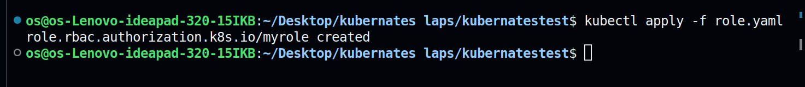

3. Link the Role with the created SA

apiVersion: rbac.authorization.k8s.io/v1
kind: RoleBinding
metadata:
name: role-binding
namespace: lab3
subjects:
- kind: serviceAccount
name: cronjob-sa
namespace: lab3
roleRef:
kind: ClusterRole
name: myrole
apiGroup: rbac.authorization.k8s.io

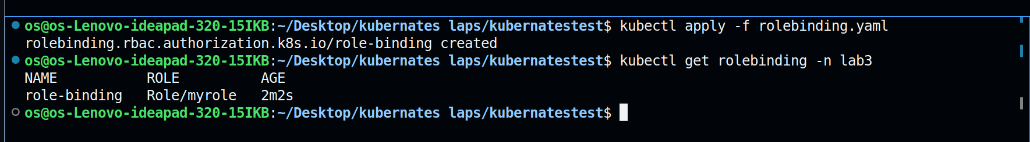

4. Create a CronJob that lists the endpoints in that namespace every minute and paste the output for the first pod created

apiVersion: batch/v1
kind: CronJob
metadata:
name: cj
namespace: lab3
spec:
schedule: "* * * * *"
jobTemplate:
spec:
template:
spec:
serviceAccountName: cronjob-sa
containers:
- name: crone-container
image: bitnami/kubectl
imagePullPolicy: IfNotPresent
command: ["kubectl","get","endpoints"]
restartPolicy: OnFailure

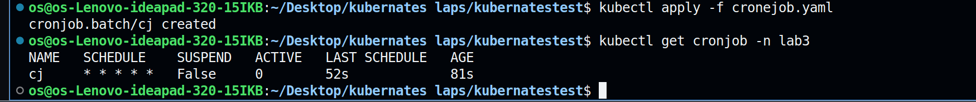

5. After listing try to delete the 3 nginx pods ? again try to view the logs for the newly created pod for that cronJob what do you think happened ?
